Algorithm for file updates in Python

Project description
Creating an algorithm to update the ip addresses in the allow_list.txt which has access to restricted content like patient records and also include a function to remove ip addresses from the allow_list.txt file.

Open the file that contains the allow list
The file that contains allowed Ip addresses is in text format and name of the file is allow_list.txt.
Now assign the document to a variable.

Note:- Basically all file names are strings in python so when we are assign the file to a variable we need to put it like string format.

Now assign the ip addresses that need to be removed from the allow_list.txt.

Read the file contents
Now to read the contents in file we need to parse it means to change it into readable format.
For this we use the “with statement” with open function using read parameter.
Syntax:- with open(import_file, "r") as file:

With- For file handling and management and closing the file.
Open - To open the file by passing the arguments, The first argument will be the file name which we need to read and second argument will be reading operator.
As- keyword to use in the with statement.
File- with statement variable.

So the following program will be like. 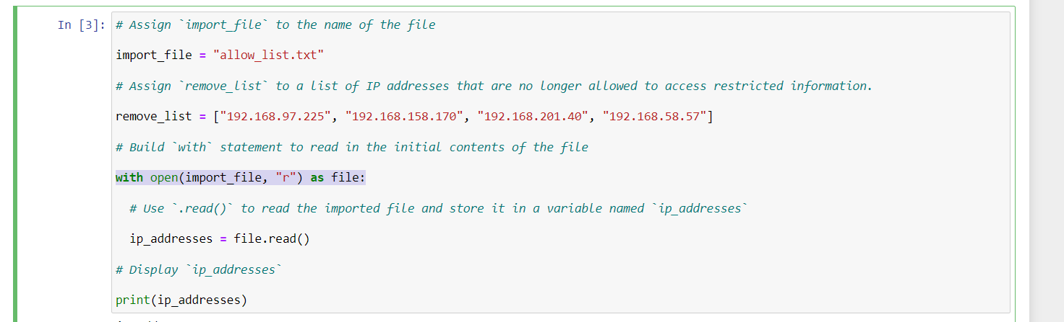
Output:-
ip_address
192.168.25.60
192.168.205.12
192.168.97.225
192.168.6.9
192.168.52.90
192.168.158.170
192.168.90.124
192.168.186.176
192.168.133.188
192.168.203.198
192.168.201.40
192.168.218.219
192.168.52.37
192.168.156.224
192.168.60.153
192.168.58.57
192.168.69.116

Convert the string into a list
The output is displayed in the string format but the string is immutable to changes so we need to change the output into the list, so we can make changes in the data.
To convert the string into list we use following method.
Here we are assigning the string data as list to the same variable by using split() functionality.

Iterate through the remove list
We have to create an iterative statement to check through the ip addresses list to remove some ip addresses by comparing them with removal ip addresses list.
We are using “for loop” to iterate through the process. 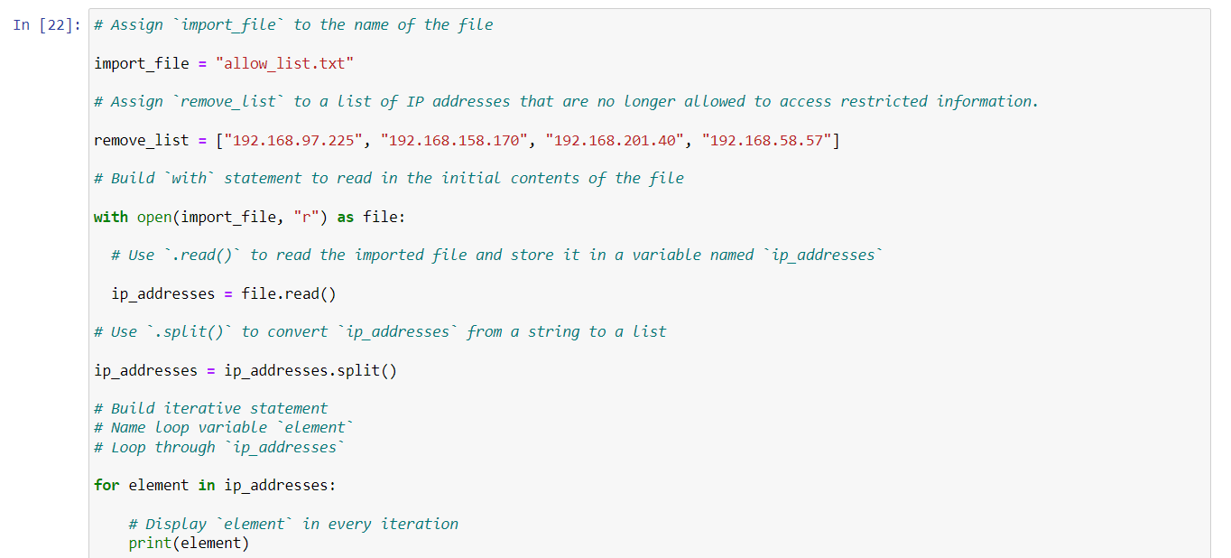
Here in for loop I used “element” as loop variable to iterate through the list.

Remove IP addresses that are on the remove list
By using If conditional statement in the for loop we are going to remove the ip addresses from the list iterating through out the allow_list.txt file, And by using .join method we change the list data into the string data.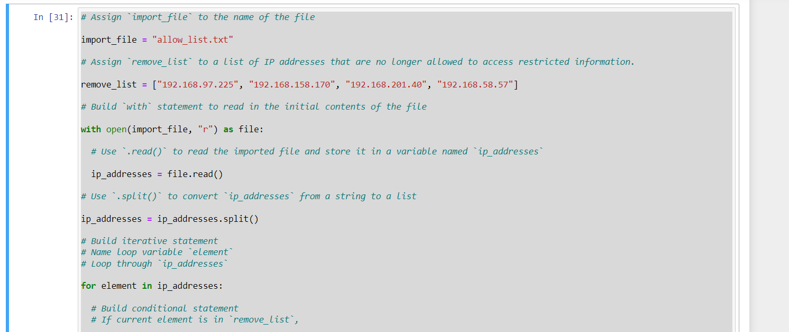 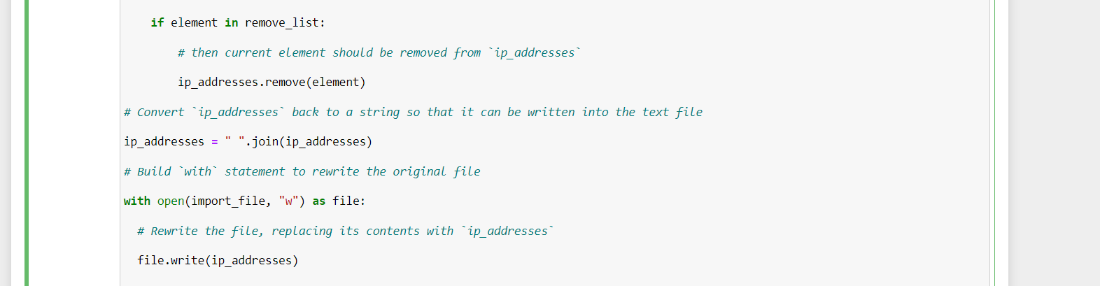

Update the file with the revised list of IP addresses
Now the output is displayed as the string data in the text variable we are going to rewrite this data into the allow_list.txt file and check the data is changed or not. 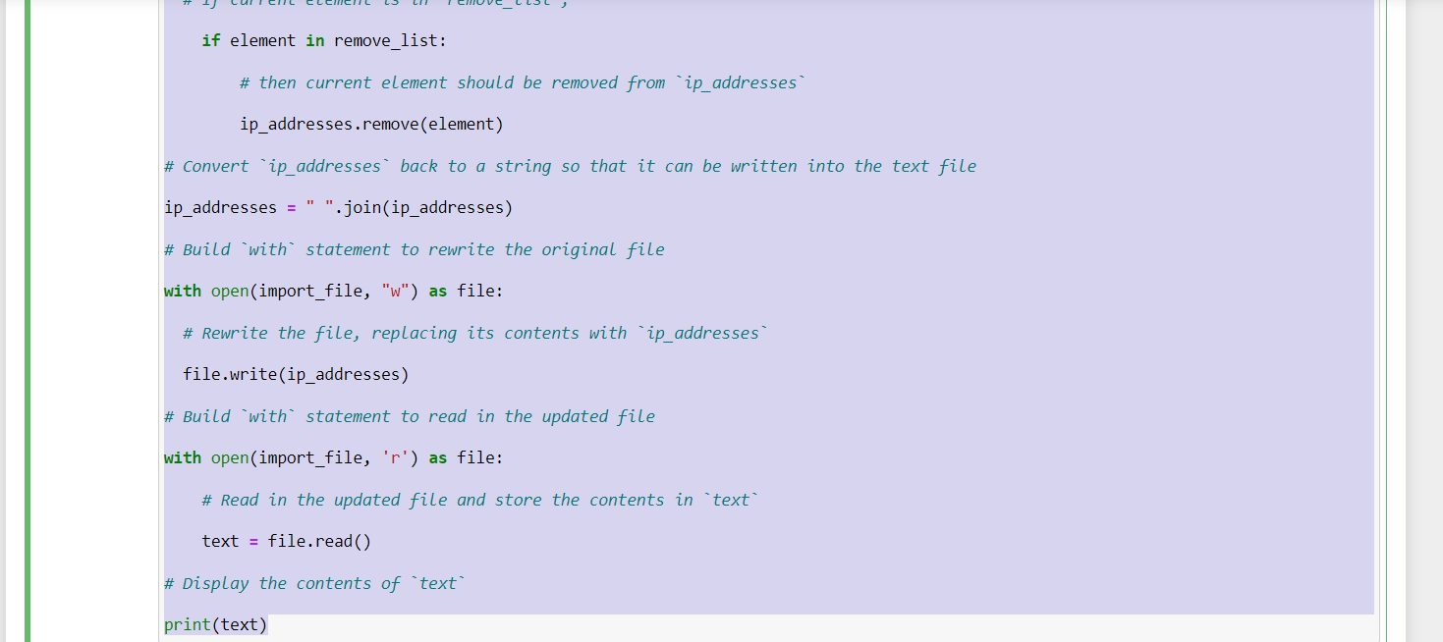
Output:- ip_address 192.168.25.60 192.168.205.12 192.168.6.9 192.168.52.90 192.168.90.124 192.168.186.176 192.168.133.188 192.168.203.198 192.168.218.219 192.168.52.37 192.168.156.224 192.168.60.153 192.168.69.116

Using the Algorithm for Automation.
By automating this algorithm process we can easily remove the ip addresses from the list when they don’t have access any more.
We can do this process by defining this algorithm as user defined function. 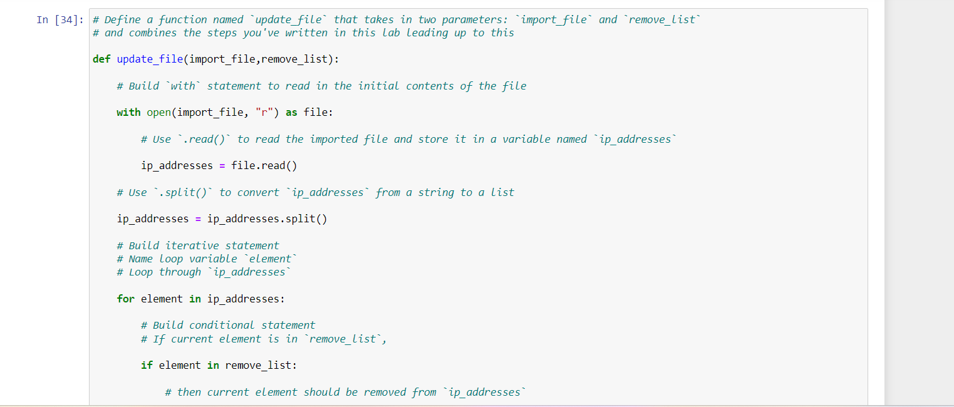 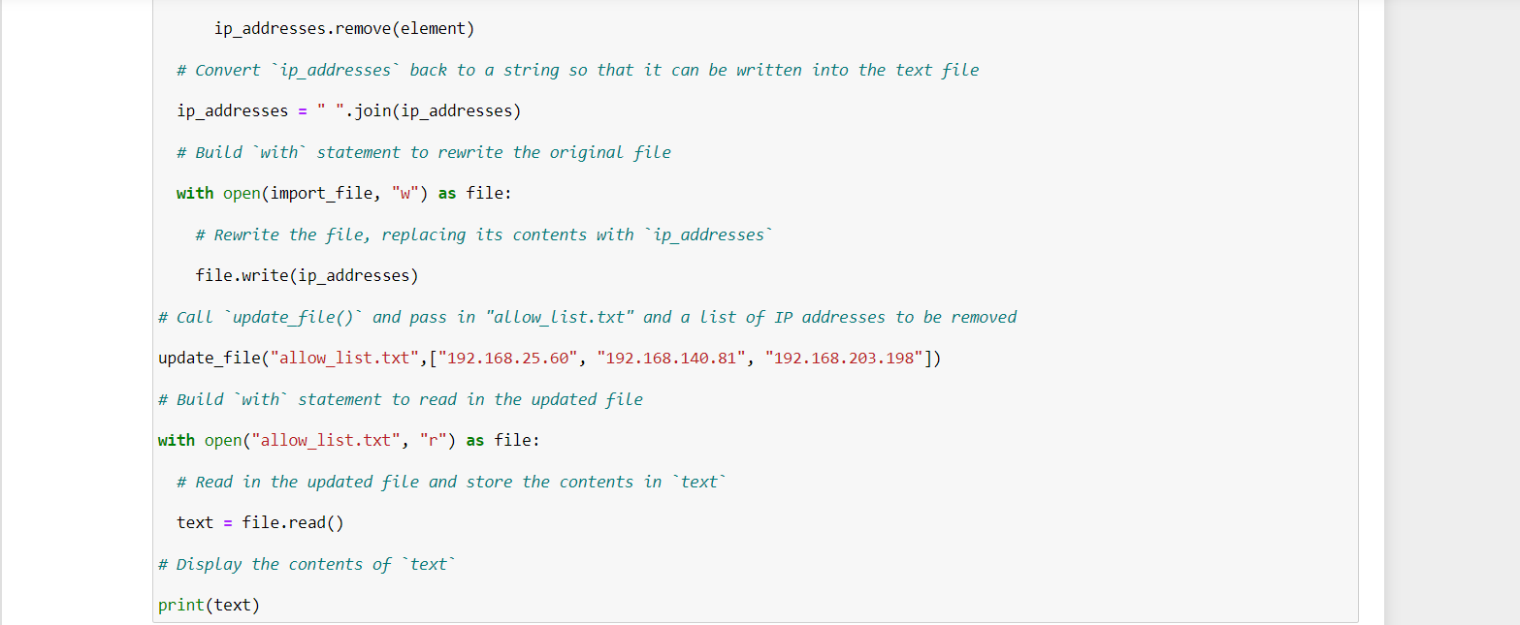

Output:- ip_address 192.168.205.12 192.168.6.9 192.168.52.90 192.168.90.124 192.168.186.176 192.168.133.188 192.168.218.219 192.168.52.37 192.168.156.224 192.168.60.153 192.168.69.116

Summary
In this scenario, as a security professional at a healthcare company, my role involves managing access to restricted content, such as personal patient records, using IP address restrictions. Employees are granted access based on an allow list, while those who must be denied access are listed in a remove list. My task is to create a Python algorithm to check whether any IP addresses listed for removal are present in the allow list. If any matches are found, these IPs should be removed from the allow list file. This algorithm ensures that only authorized personnel can access sensitive data, enhancing the security measures of the healthcare company.

